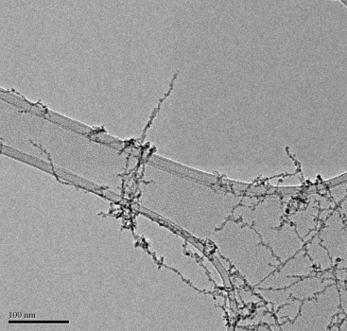
An overview of our recent work on using helium droplets to construct and deposit nanoscale objects will be provided. In terms of nanoparticles the emphasis will be on the search for magnetic materials, where the synthesis and deposition exploits some of the unique properties of helium to create new types of magnetic nanosystems. For larger helium droplets the formation of elongated objects, culminating in nanowires with lengths up to several hundred nm, will be discussed and examples for several metals will be presented. A TEM image of deposited nanowires is shown opposite.
The available evidence suggests that these chains, extending up to hundreds of nm in length but very narrow (<10 nm), are formed by the ‘pinning’ of dopant atoms to quantized vortices present in the helium droplets. The formation of both segmented chains and quasi-continuous nanowires is seen and the mechanism by which these grow will be discussed.

